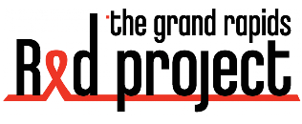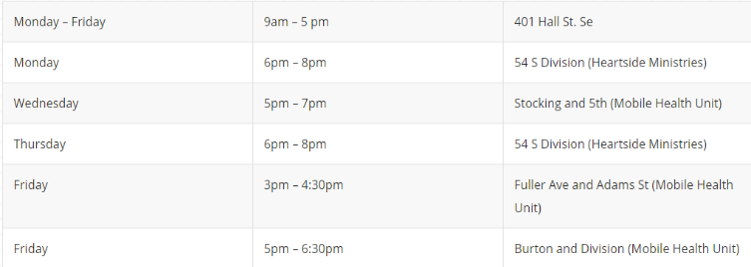**FRONT**

**BACK**

Location(s) and Hours of Operation  
*No Appointment Necessary*

Naloxone (Narcan®) saves lives! This medication rescues friends and family from an opioid overdose. Free and available 6 days a week!

Phone: (616) 456-9603  
Email: [info@redproject.org](mailto:info@redproject.org)