**Free Naloxone (NARCAN®) Available upon Request**

It is often administered nasally under the brand name NARCAN®

Naloxone is an FDA-approved antidote medication that is nearly 100% effective in reversing the effects of an opioid.

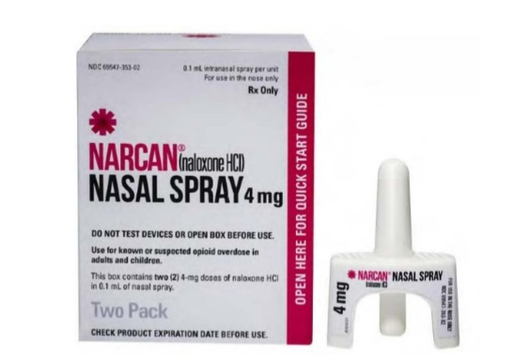

**What is Naloxone?**

**How does it work?**

**Victory Clinical Services**

*3300 Lansing Avenue · Jackson, MI 49202*

*517-784-3030*

Victory Clinic provides optimal outpatient services for individuals with opioid use disorders through medicated assisted treatment and an integrated network of care.

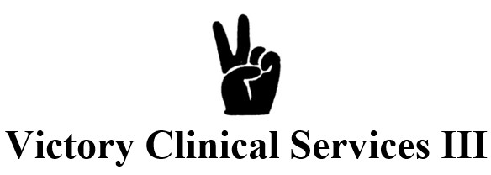

**Mid-State Health Network**

*1-844-405-3095*

The above Access Management System (AMS) agency will answer questions regarding alcohol and drug use, and discuss options for those needing treatment services. If services are determined to be appropriate, the agency will assist callers in choosing a provider that meets their needs, and will make the necessary referral.

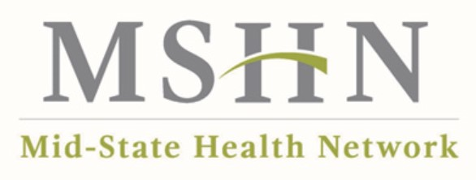

Yes – Naloxone has no risk for misuse.

Naloxone only works if a person has opioids in their system; the medication has no effect if opioids are absent.

Naloxone is FDA-approved medication.

**Is it safe?**

Following a brief training, Naloxone can be safely administered by people who use, or know of a person who uses opioids, first responders, medical providers, behavioral health providers, and lay persons.

**Who can use it?**

**Right here, at the Jackson County Jail!** Ask the on-duty officer for your free kit.

Free Naloxone is also made available by local Prepaid Inpatient Health Plans (PIHP), community organizations and non-profit organizations.

Individuals may access Naloxone from their local pharmacy without a prescription.

**Where can I get a Naloxone Kit?**

Naloxone is an opioid antagonist that works by attaching to opioid receptors to block and reverse the effects of opioids.

It can quickly save a person if their breathing has slowed or stopped because of an opioid overdose.

**Where can I get addiction help for opioid use disorder (OUD), locally?**